Ethics in Research Workshop

Speaker: Dr. Anant Kukreti, Director for Engineering Outreach,
Professor, Department of Biomedical, Chemical, and Environmental Engineering
Date: Wednesday, June 22, 2016
Time: 9:00 – 9:45 AM
Venue: University of Cincinnati, Swift Hall room 516

Prepared by:
James Prugh, Indian Hill High School, Cincinnati, Ohio
RET Participant for Project #4: “Cyberspace Security”

The session was presented by Dr. Anant Kukreti, Director for Engineering Outreach and Professor in the Department of Biomedical, Chemical, and Environmental Engineering at the University of Cincinnati. Dr. Kukreti has been instrumental in securing large amounts of grant money, including a 5-year NSF grant, for the University. Dr. Kukreti shared information and insights on ethics in research.

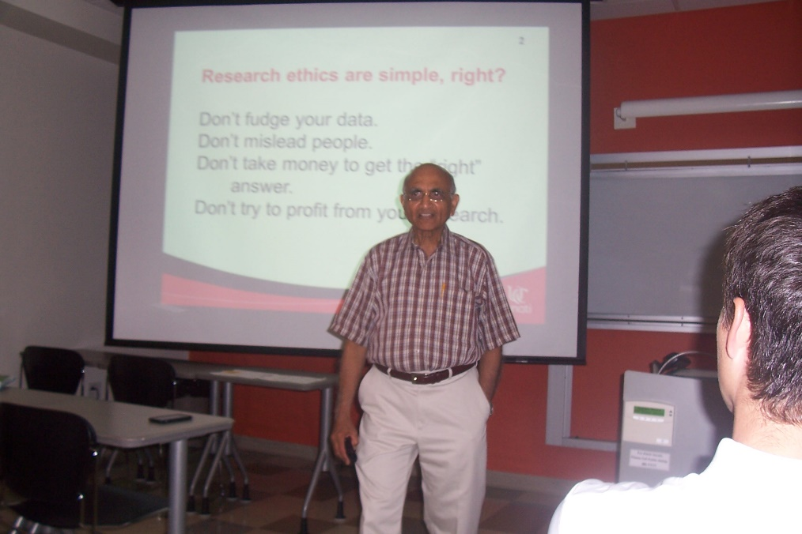

Figure 1. Dr. Kukreti introduces the topic of ethics in research.

Dr. Kukreti began by comparing and contrasting misconduct and unethical behavior. He was quick to point out that honest errors are not considered misconduct. The key is intent to deceive and use of the research for personal gain. An example of misconduct might be hiring a family member in a research project. Misconduct is usually a punishable offense. Unethical behavior is more about fairess and not necessarily misconduct. Errors are not considered misconduct, but failure to report errors might be.

Next, Dr. Kukreti presented and elaborated on some of the points from the following list of guiding principles from Resnick:

- Honesty
- Objectivity
- Integrity
- Carefulness
- Openness
- Respect for Intellectual Property
- Confidentiality
- Responsible Publication
- Responsible Mentoring
- Respect for Colleagues
- Social Responsibility
- Non-Discrimination
- Competence
- Legality
- Animal Care

Dr. Kukreti followed this with his thoughts on the principles above. He emphasized that all of us should strive for honesty in all scientific communications. This includes disclosure and retention of records of all data. Avoiding bias is also of utmost importance. Although we can never be 100% objective, we must minimize bias. Confidentiality must be protected in papers, grants submitted for publication, personal records, trade of military secrets, and patent records. Dr. Kukreti warns us that there are those who will steal the work of others. Competence implies that we keep up to date with the information and research that surrounds us.

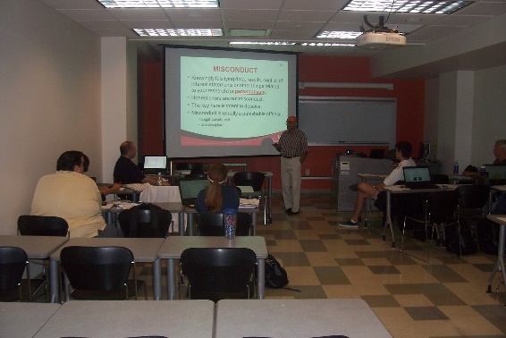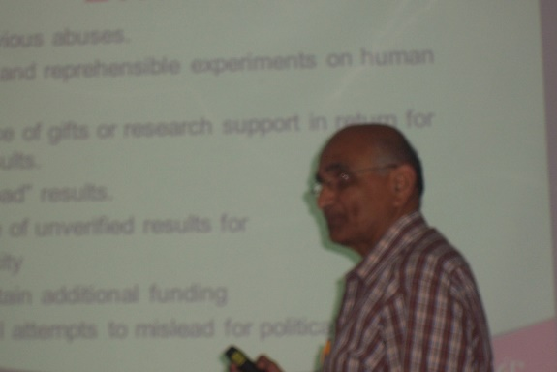

Figure 2. Dr. Kukreti address the RET group Figure 3. Dr. Kukreti discuss guiding principles

Finally, Dr. Kukreti discussed the implications of human subject and animal care and protection. All persons involved must be fully aware of their involvement, and their consent is required. Subjects must be made aware of the intent and findings of the research.

In conclusion, Dr. Kukreti points out that we must consider ethics when conducting research, reporting findings, collecting data, involving people in your research.

